Phase 3: Defensive Strategy Implementation and Attack Mitigation

Catalog
1: Choose a Defense Strategy 2
2: Snapshot the “Before” Situation 2
2.1 On Kali terminal, type: 2
2.2 On Metasploitable3 terminal, type: 3
2.3 Scan for open ports on victim 3
2.4 Use Hydra to perform brute force attack 4
2.5 Log into FTP using found password 4
2.6 Add the log to your victim log file 4
3: Install Fail2Ban on Metasploitable3 4
3.1. Open terminal in Metasploitable3 4
3.2 Configure Fail2Ban to protect FTP 5
3.3. Restart Fail2Ban 5
4: Rerun the Attack from Kali 5
5: Compare Before and After 6
5.1 Before : 6
5.2 After: 6

1: Choose a Defense Strategy
- Let’s pick a simple and effective one:

We will use Fail2Ban — a tool that blocks brute-force attackers.
- Fail2Ban will monitor failed login attempts and block the attacker’s IP (Kali) if it keeps failing login.
- 📌 We’ll install this on Metasploitable3 (the victim).

2: Snapshot the “Before” Situation
·Set their network to NAT or “Host-only Adapter” so they can talk to each other.

2.1 On Kali terminal, type:
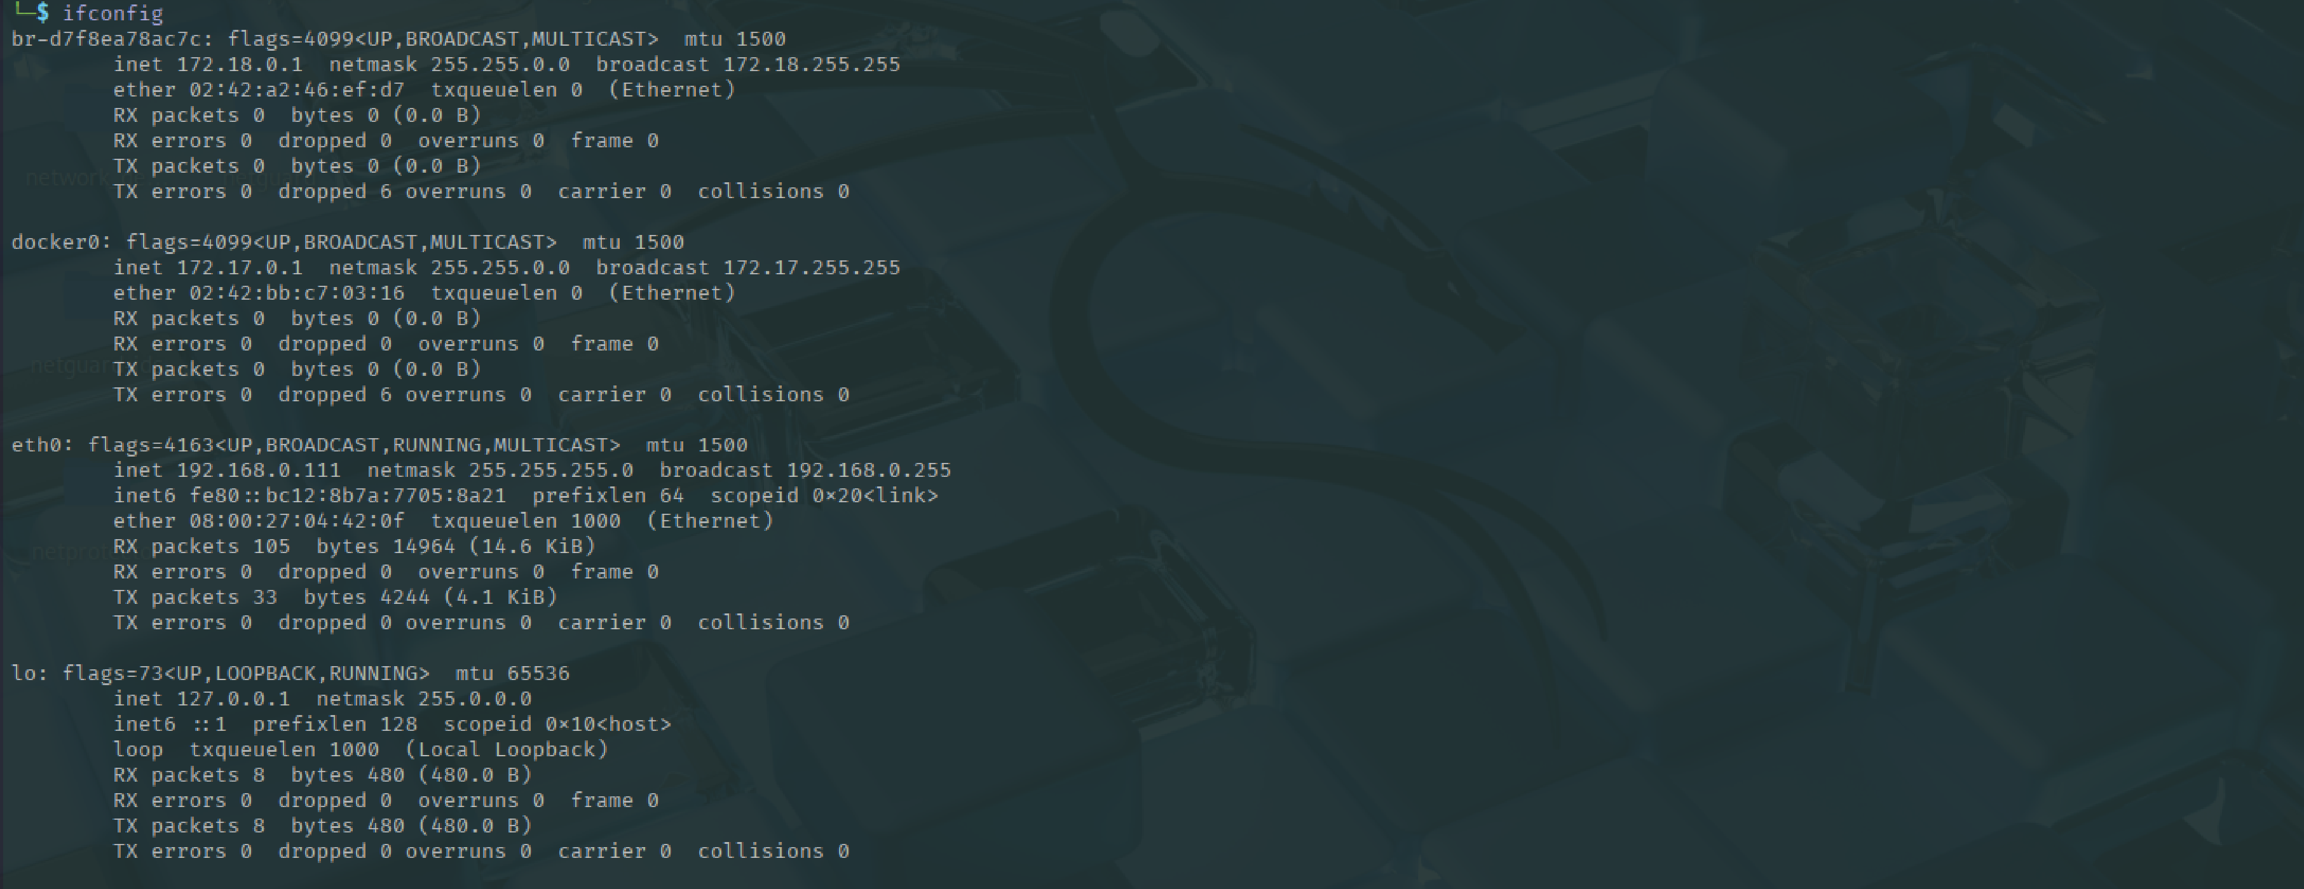

2.2 On Metasploitable3 terminal, type:
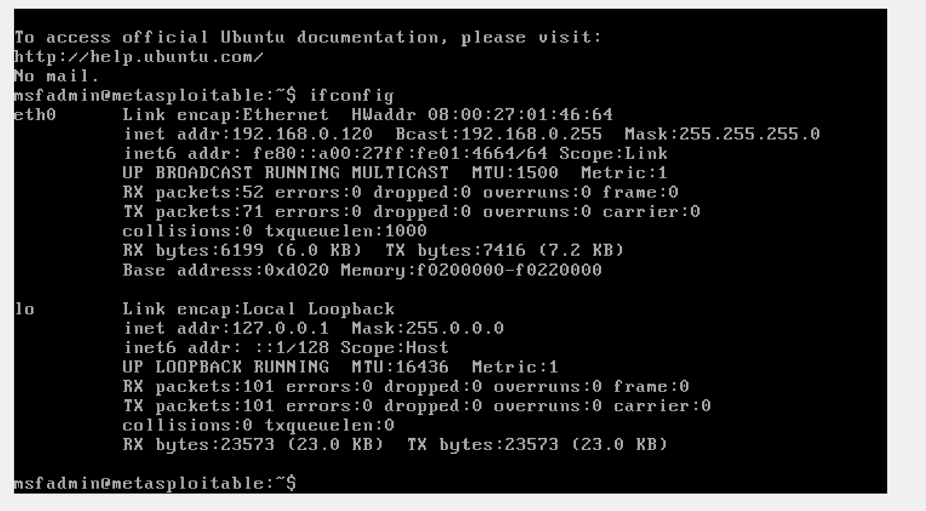

2.3 Scan for open ports on victim

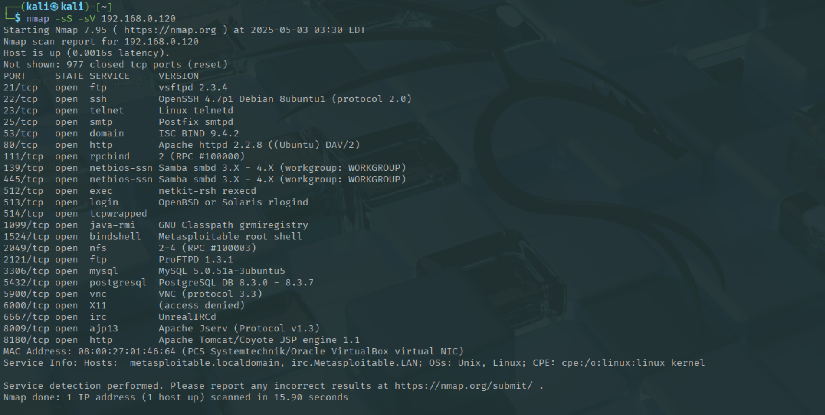

2.4 Use Hydra to perform brute force attack
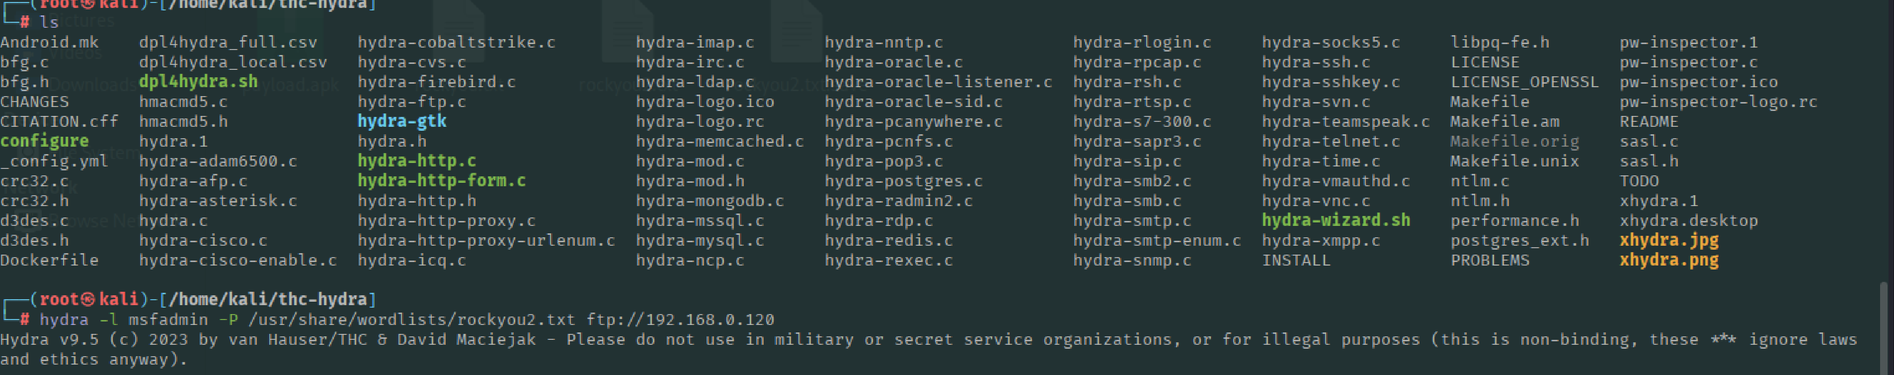

2.5 Log into FTP using found password
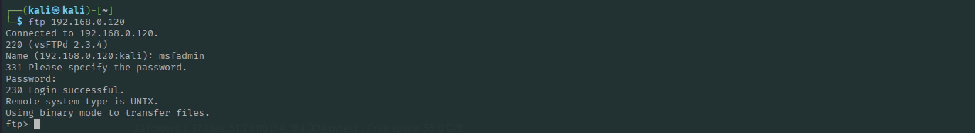

2.6 Add the log to your victim log file

3: Install Fail2Ban on Metasploitable3

3.1. Open terminal in Metasploitable3
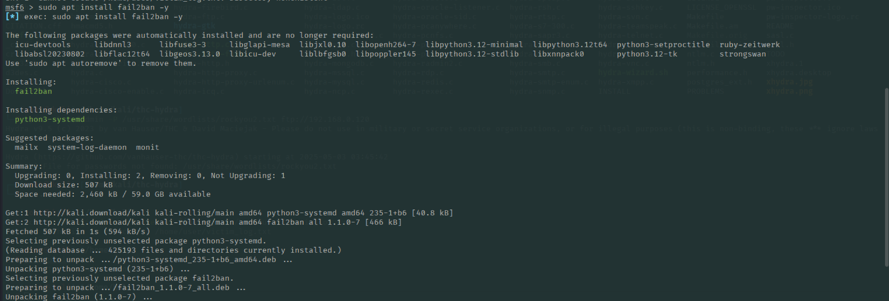

3.2 Configure Fail2Ban to protect FTP
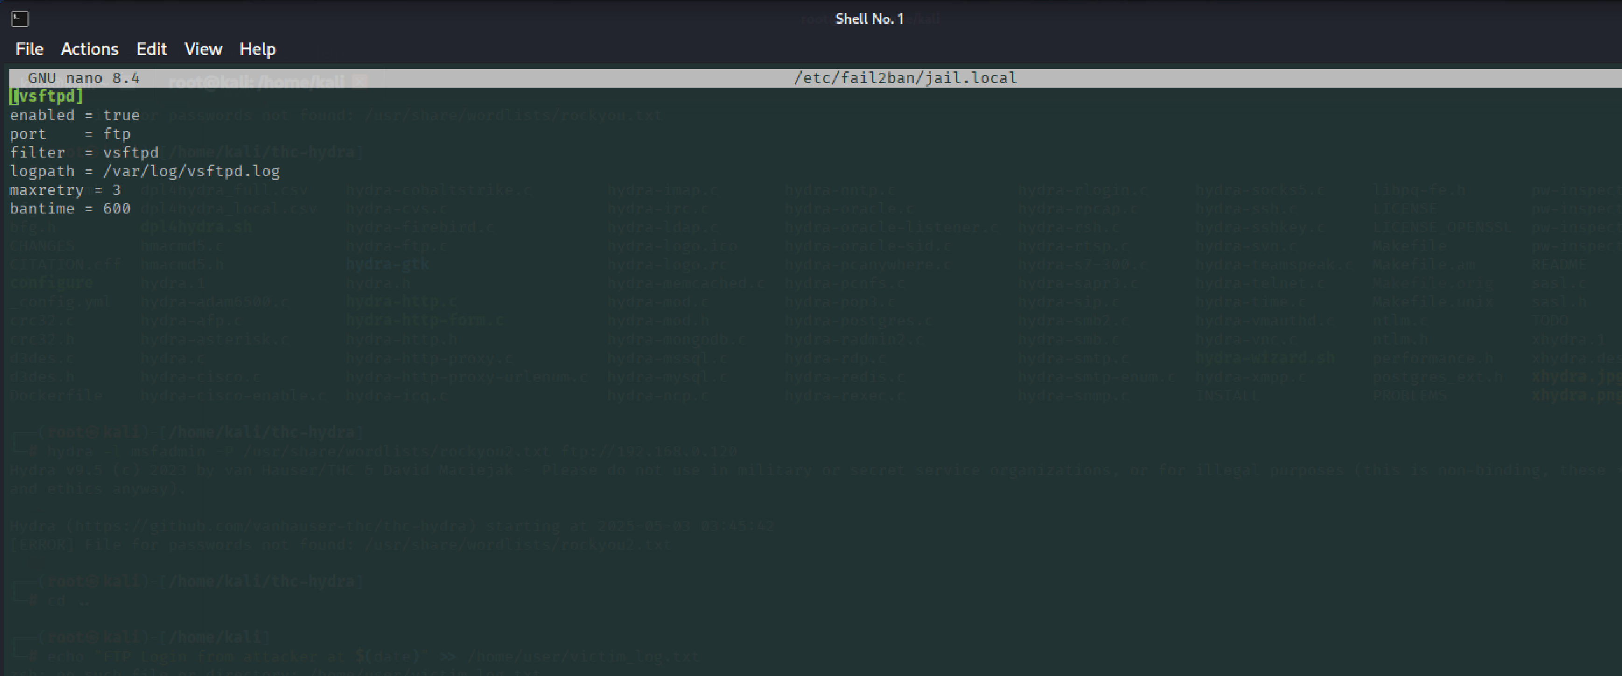

3.3. Restart Fail2Ban

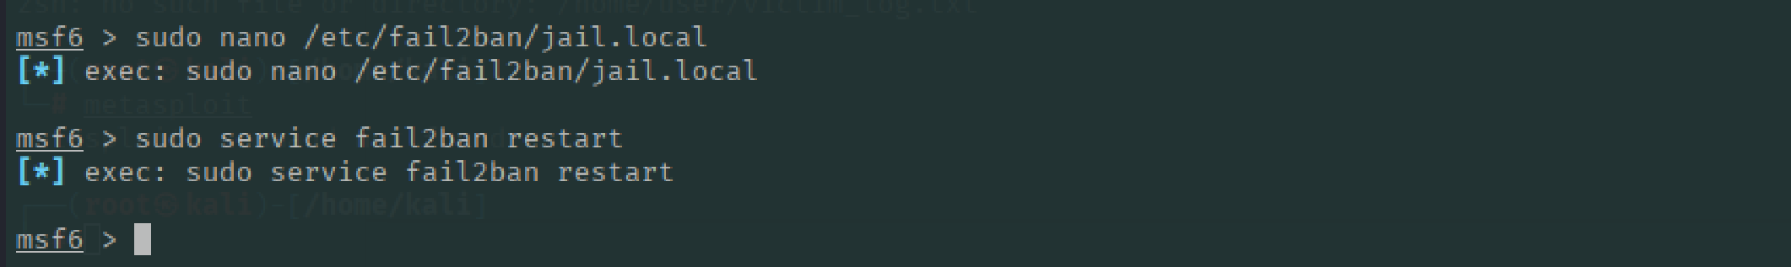

4: Rerun the Attack from Kali
- Run the exact same FTP attack from earlier
- This time, after 3 failures, Kali’s IP will be blocked

5: Compare Before and After

5.1 Before :

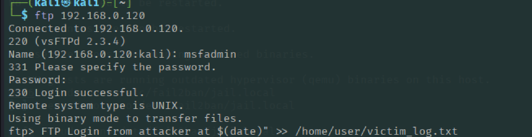

5.2 After:

